Computer Science Project Report
School Attendance System 2025-26

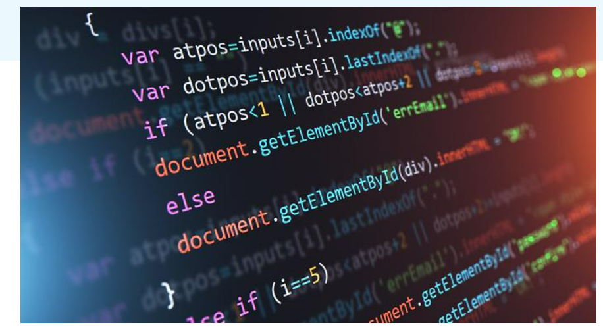

Declaration

I hereby declare that the project work entitled, “SCHOOL ATTENDANCE SYSTEM”, Submitted to the DEPARTMENT OF PHYSICS, Orchard school is carried out by me. This work has not been submitted earlier in full or in part.

Sivanuja.S

Acknowledgement

I would like to express our special thanks of gratitude to our school principal MRS.SILVIE NESA as well as to our computer teacher MRS.JENNIFER who gave the golden opportunity to do this wonderful project on this topic ‘SCHOOL ATTENDANCE SYSTEM’ Which also helped me in a lot of research work and I came to know about so many new things. I am really thankful to them.

Sivanuja .S

Certificate

This is to certify that, the bonafide record of project work done by Sivanuja S of Grade 12 during the academic year 2025 – 2026. Submitted for AISSCE Physics Practical Examination held on __/__/2025 at Orchard School (CBSE), Iyer Thottam, Trichy-21.

Date:
Internal Examiner External Examiner

Principal

INDEX

Serial Number | Topic | Page Number
1 | Introduction | 1
2 | Program | 3
3 | Analysis | 5
4 | Conclusion | 8
5 | Bibliography | 9

INTRODUCTION

In the modern era of digital transformation, maintaining manual attendance registers has become outdated and prone to errors. The school attendance system project aims to automate the traditional method of attendance management. This system helps reduce paperwork, increases accuracy, and saves time for teachers and administrative staff.

Attendance is a critical part of school management, ensuring that students are present for learning and that their participation is documented for academic records. In traditional systems, attendance is marked manually on registers, which is time-consuming, prone to human error, and difficult to analyse for long-term patterns.

This investigatory project aims to build a School Attendance System using the Python programming language, leveraging a GUI (Graphical User Interface) for interaction and CSV files for data storage. The goal is to automate attendance marking and provide easy access to reports, which helps both teachers and administrators manage classroom attendance more efficiently.

CODING

Create Database & Table (MySQL)

CREATE DATABASE school;

USE school;

CREATE TABLE attendance
(Id INT AUTO_INCREMENT PRIMARY KEY,
Student_name VARCHAR(50),
Status VARCHAR(10));

Install MySQL Connector (one time)

Command Prompt:
pip install mysql-connector-python

Python Program with MySQL Connector
Import mysql. Connector

Con = mysql.connector.connect
(Host=”localhost”,
User=”root”,
Password=””, # default password in XAMPP is empty
Database=”school”)

Cursor = con.cursor()

Students = [“Alice”, “Bob”, “Charlie”, “Diana”]
Attendance = {}

Print(“School Attendance System”)
Print(“------------------------“)

For student in students:
Status = input(f”Is {student} present? (P/A): “).strip().upper()

If status == ‘P’:
Attendance[student] = “Present”
Elif status == ‘A’:
Attendance[student] = “Absent”
Else:
Attendance[student] = “Invalid”

Query = “INSERT INTO attendance (student_name, status) VALUES (%s, %s)”
Values = (student, attendance[student])
Cursor.execute(query, values)

con.commit()

Print(“\nToday’s Attendance Report:”)
For student, status in attendance. items():
Print(f”{student}: {status}”)

con.close()

ANALYSIS

The School Attendance System is created to make the process of marking attendance easy and accurate. In the manual system, attendance is written in registers, which takes more time and may cause mistakes. This program helps to solve these problems by using a computer-based method.

In this program, Python is used to take attendance input from the user, and MySQL is used to store the attendance records permanently. A list of students is already defined in the program. The user marks each student as Present or Absent using simple input options (P or A).

The program checks the input and stores the attendance in both a dictionary and a MySQL database using the MySQL connector. This makes the system reliable and organized. After marking attendance, the program displays the attendance report on the screen.

Overall, this system reduces manual work, saves time, and keeps attendance records safe. It is simple to use and can be improved in the future by adding features like date-wise attendance, student details, and automatic report generation.

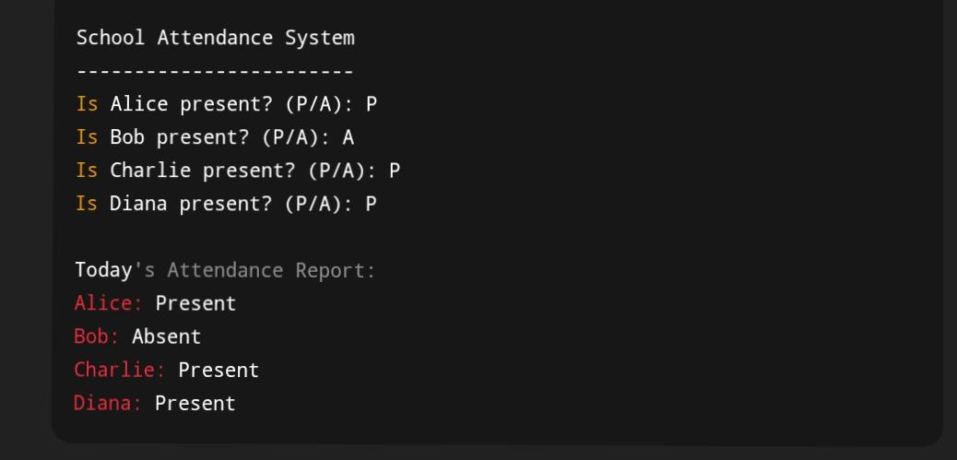
OUTPUT
Modules Used in This Program

mysql. Connector

- Used to connect Python with MySQL database

- Helps in executing SQL queries from Python

- Required for database operations like INSERT, SELECT

Built-in Python Modules

- Input() – to take user input

- Print() – to display output

- Dictionary (dict) – to temporarily store attendance

- Functions – for modular programming

CONCLUSION

In conclusion, The School Attendance System developed as part of this Computer Science project successfully meets its objective of maintaining and managing student attendance in an efficient and systematic manner. This system reduces manual work and minimizes errors that usually occur in traditional attendance registers. By using programming concepts and database management, attendance records can be stored, retrieved, and updated easily.

The project helped In understanding important concepts such as data handling, conditional statements, loops, and basic database operations. It also showed how computer applications can be used to solve real-life problems in schools. Overall, this project enhanced my practical knowledge and improved my logical thinking and problem-solving skills.

In future, this system can be further improved by adding features like student login, automatic report generation, and integration with biometric or online attendance systems.

Bibliography

Python:
• GeeksforGeeks. "School Attendance System in python Code with Explanation".
– https://www.geeksforgeeks.org/school-attendance-system-in-cpp/
(Accessed: Dec 2025)
– Used for example code structure and database operations.
• W3Schools. "SQL Tutorial – Database Management".
– https://www.w3schools.com/sql/
(Accessed: Dec 2025)
– Used for understanding SQL queries in project database.

